Riley Snowe

CS 499

Southern New Hampshire University

29 May 2022

Milestone Three

The second artifact comes from the same CS 405 class regarding exceptions. The assignment was from the fourth week in the class where we had to write code that handled different types of exceptions, including unknown exceptions.

This artifact was chosen as it is very good to understand in detail. My CS 405 class did not go as in-depth as I would have liked with the assignment. When looking at the artifact from what was initially created, there are some improvements that can be made. As stated in the code review, I believe that exceptions could be better named for the uncaught exceptions.

Exceptions happen where there are events that should not normally take place, such as an unplanned event. When exceptions occur, it breaks the program by disrupting the normal flow of the program. The best practice is working with the exceptions that are known, but sometimes that is not possible. In the case of the artifact, one specification was to catch unknown exceptions, which it can do. When searching different ways to try and name the unknown exceptions, it would fall outside the scope of the assignment. Looking through information of different programs that have some ability to do this, there is a lot of back tracing and rethrowing of exceptions.

Initially I stated there could be enhancements where the exceptions could further name what the exceptions are. Reviewing the code and other projects that focus on the same idea, what is currently coded is the most efficient for the program it was made for. There are the cases of nothrow, which can increase performance, but is the same concept of what my current program consists of.

What I did change to make my current application a bit better is the comments. I expanded upon the existing comments to further detail what each sections outcome should be. The additional comments will help readability and understanding of the code.

The next page shows pictures of the program before and after changes. The only changes made are to the comments to include more detail.

Before Changes:

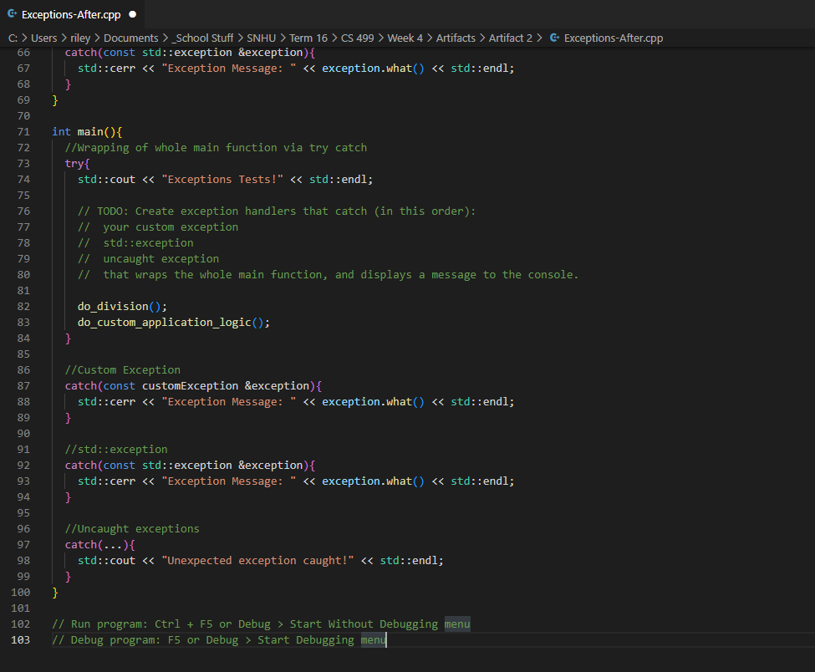

After Changes:

